Experiment 6: Outlier Detection and Treatment (Z-score, IQR)
ED408 — Statistical / Supervised Machine Learning Lab
Aim: Detect and treat outliers in a dataset using the Z-score method and the IQR method.
Dataset Used: BSDS500 (Berkeley Segmentation Data Set) ships as natural images with hand-annotated object-boundary ground truth, not a tabular dataset. It was converted into a tabular binary-classification dataset (data/bsds_features.csv, built by scripts/build_dataset.py): one row per sampled pixel from all 200 BSDS500 training images, 10 features (R, G, B, gray, grad_mag, grad_dir, laplacian, local_std, x_norm, y_norm) capturing colour, gradient, texture and position, and label is_edge (1 if a majority of 6 human annotators marked the pixel as a segment boundary, else 0). 24,000 rows total, perfectly balanced (12,000 / 12,000). This same dataset is reused, unchanged, for every question in this lab.
Theory
Z-score method: flag a value as an outlier if |z| = |(x - mean)/std| > 3, i.e. more than 3 standard deviations from the mean (assumes roughly normal data). IQR method: flag a value as an outlier if it falls outside [Q1 - 1.5*IQR, Q3 + 1.5*IQR], where IQR = Q3 - Q1 (distribution-free, robust to skew). Treatment here is winsorizing: outliers are capped at the IQR fences rather than dropped, to avoid shrinking the dataset.
Code
"""
Q6 — Detect and treat outliers in the BSDS500-derived edge-pixel dataset
using the Z-score method and the IQR method.
"""
import numpy as np
import pandas as pd
import matplotlib.pyplot as plt

from common import DATA_CSV, FIG_DIR, save_metrics

# grad_dir is circular (radians, -pi..pi) and x_norm/y_norm are positional —
# outlier analysis is only meaningful for the continuous magnitude features.
OUTLIER_COLS = ["R", "G", "B", "gray", "grad_mag", "laplacian", "local_std"]
Z_THRESH = 3.0
IQR_K = 1.5

def zscore_outliers(series):
z = (series - series.mean()) / series.std()
return z.abs() > Z_THRESH

def iqr_outliers(series):
q1, q3 = series.quantile(0.25), series.quantile(0.75)
iqr = q3 - q1
lower, upper = q1 - IQR_K * iqr, q3 + IQR_K * iqr
return (series < lower) | (series > upper), lower, upper

def main():
df = pd.read_csv(DATA_CSV)
summary = {}
df_treated = df.copy()

for col in OUTLIER_COLS:
z_mask = zscore_outliers(df[col])
iqr_mask, lower, upper = iqr_outliers(df[col])

# Treatment: cap (winsorize) IQR-flagged values at the fences.
df_treated[col] = df[col].clip(lower=lower, upper=upper)

summary[col] = {
"n_outliers_zscore": int(z_mask.sum()),
"pct_outliers_zscore": float(100 * z_mask.mean()),
"n_outliers_iqr": int(iqr_mask.sum()),
"pct_outliers_iqr": float(100 * iqr_mask.mean()),
"iqr_lower_fence": float(lower),
"iqr_upper_fence": float(upper),
}
print(f"{col:10s} zscore={z_mask.sum():4d} ({100*z_mask.mean():.2f}%) "
f"iqr={iqr_mask.sum():4d} ({100*iqr_mask.mean():.2f}%) "
f"fences=[{lower:.3f}, {upper:.3f}]")

# ---------- before/after boxplots ----------
fig, axes = plt.subplots(1, 2, figsize=(14, 5))
df[OUTLIER_COLS].boxplot(ax=axes[0], rot=45)
axes[0].set_title("Before treatment")
df_treated[OUTLIER_COLS].boxplot(ax=axes[1], rot=45)
axes[1].set_title("After IQR-capping (winsorized)")
plt.suptitle("Outlier treatment: box plots before vs after")
plt.tight_layout()
plt.savefig(FIG_DIR / "q6_outlier_boxplots.png", bbox_inches="tight")
plt.close()

# bar chart comparing method counts
fig, ax = plt.subplots(figsize=(8, 4.5))
x = np.arange(len(OUTLIER_COLS))
width = 0.35
z_counts = [summary[c]["n_outliers_zscore"] for c in OUTLIER_COLS]
iqr_counts = [summary[c]["n_outliers_iqr"] for c in OUTLIER_COLS]
ax.bar(x - width/2, z_counts, width, label="Z-score (|z|>3)")
ax.bar(x + width/2, iqr_counts, width, label="IQR (1.5x)")
ax.set_xticks(x); ax.set_xticklabels(OUTLIER_COLS, rotation=45, ha="right")
ax.set_ylabel("# outliers detected")
ax.set_title(f"Outlier counts by method (n={len(df)})")
ax.legend()
plt.tight_layout()
plt.savefig(FIG_DIR / "q6_outlier_counts.png", bbox_inches="tight")
plt.close()

treated_path = DATA_CSV.parent / "bsds_features_outliers_treated.csv"
df_treated.to_csv(treated_path, index=False)
print(f"saved treated dataset -> {treated_path}")

save_metrics("q6_outliers", {"per_feature": summary, "total_rows": len(df)})

if __name__ == "__main__":
main()
Output
Feature | Z-score outliers | IQR outliers
R | 0 | 0
G | 0 | 0
B | 0 | 0
gray | 0 | 0
grad_mag | 478 | 1352
laplacian | 500 | 1562
local_std | 230 | 541

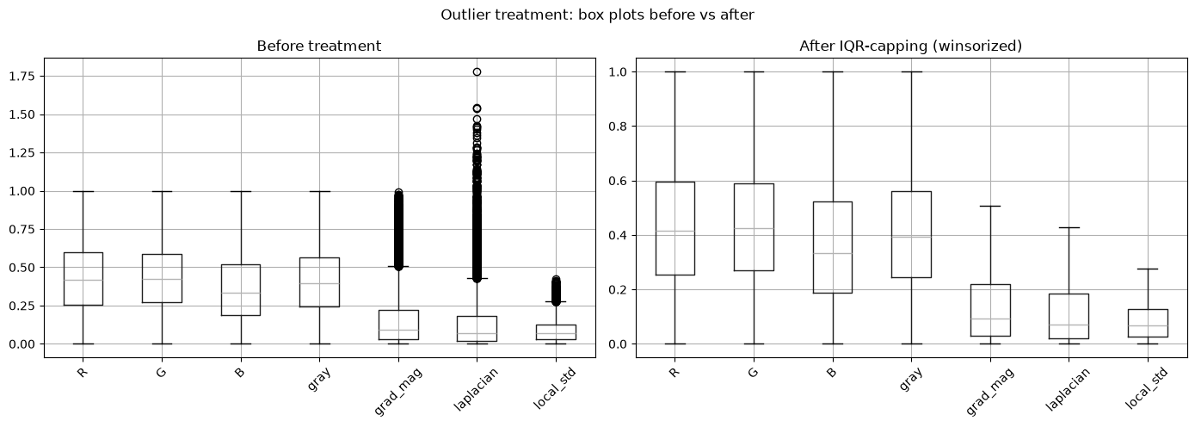
Box plots before vs. after IQR-capping.
Result
Colour features (R, G, B, gray) contain essentially no outliers (bounded [0,1] range), while gradient/texture features (grad_mag, laplacian, local_std) show 2-6% outliers under IQR, consistent with their right-skewed distributions (most pixels are flat, a minority are sharp edges). IQR consistently flags more points than Z-score here because these features are non-normal / skewed.

